**Assignment 1 Report**

**Question 1**

* **Requirements for each task in this section**

1. Write a script that opens a news website and a word document.
2. Write a script that deletes files from temporary internet files.

**1.1: Step-by-Step configuration/implementation**

* On the first line, I used the start command to open internet explorer and searched the news website using the URL of that website (BBC) which opens the website on the internet explorer. On the Second line, I used the start command to start WinWord which starts the Microsoft word application. On the third line, I used a pause command, so I could see if my code was working properly or not.

**1.2: Screenshots**



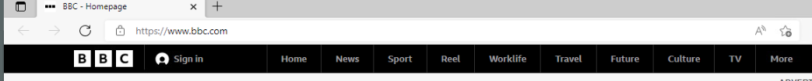

**2.1: Step-by-Step configuration/implementation**

* On the first line, I used the command DEL /F /S /Q %Temp% which deletes the contents of the temp files and folders on the for windows. On the second line, I used the pause command to see the output of the command on the first line and as well, to see if my code is working properly or not.

**2.2: Screenshots**

**Question 2**

* **Requirements for each task in this section**

1. Write a Program in which the user must enter a first name, last name, username, email ID and password. Check the password to see if it meets password requirements. Display a message if it doesn’t. Save the password in excel or notepad. Also hide the password when being entered.
2. Ask the user to log in, using the same username and password in part 1. After 3 attempts, the user must be blocked for 2 minutes. Don’t allow the user to login for the next minute. If a user attempts, show a message that your password is blocked with a message as ‘Unauthorised attempt’.

**1.1: Step-by-Step configuration/implementation**

* To do this question, I first asked the user for 4 inputs like first name and last name etc. For the password validation method, I checked every character in the password that the user gives to see if it meets the password requirements given in the question like if it contains a number or capital letter etc. I also displayed a message if the password didn’t meet the requirements. Also, if the password was valid using the method and it returned true, I wrote it to a file called Passwords.txt.

**1.2: Screen Shots**

**2.1 Step-by-Step configuration/implementation**

For this question, I first added a while loop where the user is asked for information in part 1. Then I added a counter every time the user entered their password. If the user entered their password more than 3 times, I block the user for 2 minutes using the sleep command.

**2.2: Screen Shots**

